South African Bowhunter's association
This certifies that, for _____________,

has achieved first place in this category, at SABA's 3D bow hunting competitions

1st Male BroAdhead
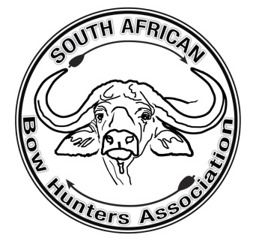
President |  | Chairman

